PROJECT REPORT
FOR
Foundations of Artificial Intelligence
AI METRO: CROWD-AWARE ROUTE PLANNER USING A* SEARCH
A PROJECT REPORT
Submitted by
240701010 – ABIRAMI L
240701023 – AJAY PRASATH P

October, 2026

BONAFIDE CERTIFICATE
Certified that this project report “AI METRO: CROWD-AWARE ROUTE PLANNER USING A* SEARCH” is the bonafide work of “ABIRAMI L (240701010) and AJAY PRASATH P (240701023)” who carried out the project work under my supervision.
SIGNATURE OF THE FACULTY INCHARGE
Submitted for the Practical Examination held on ________________
SIGNATURE OF THE INTERNAL EXAMINER
TABLE OF CONTENTS
CHAPTER NO. AND TITLE PAGE NO.
ABSTRACT 1
1. INTRODUCTION 2
2. LITERATURE REVIEW 4
3. PROPOSED SYSTEM 6
3.1 ARCHITECTURE DIAGRAM 6
3.2 PROBLEM FORMULATION AS GRAPH SEARCH 7
3.3 EDGE COST FUNCTION 7
3.4 HEURISTIC FUNCTION 8
3.5 A* ALGORITHM 8
3.6 AVAILABILITY FILTERING AND ALTERNATIVE ROUTES 9
4. MODULES DESCRIPTION 10
4.1 USER INPUT MODULE 10
4.2 METRO NETWORK DATABASE MODULE 10
4.3 CROWD INFORMATION MODULE 11
4.4 STATION AVAILABILITY MODULE 11
4.5 DYNAMIC COST CALCULATION MODULE 12
4.6 A* SEARCH ENGINE MODULE 12
4.7 ROUTE RECOMMENDATION MODULE 12
4.8 FRONT END AND VISUALISATION 12
5. IMPLEMENTATION AND RESULTS 13
5.1 EXPERIMENTAL SETUP 13
5.2 RESULTS 13
6. CONCLUSION AND FUTURE WORK 21
7. REFERENCES 22

ABSTRACT
Conventional metro route planners optimise only distance or travel time and therefore ignore how crowded a station is, whether a station is open, and how inconvenient a line change is. This project presents AI Metro, a crowd-aware route planner that applies A* search to a weighted metro network graph. Stations are nodes and connections are bidirectional edges. Each edge carries a dynamic cost equal to the sum of a travel (fare) cost, a time cost, a crowd penalty (Low = 0, Medium = 4, High = 10) and a transfer penalty applied when the passenger changes line. Stations and connections that are closed, under maintenance or disrupted are removed from the search graph before the search begins, whereas delayed ones remain with added time. A* is guided by an admissible straight-line heuristic scaled to the minimum cost per kilometre, so the route returned is optimal. The system also returns up to two alternative routes with total time, fare, crowd summary and number of transfers. A sample network of 20 stations, 3 lines and 4 interchanges was used for evaluation. Over 380 station pairs, A* returned costs identical to Dijkstra’s algorithm while expanding 42.5% fewer nodes, and in 4,044 randomised crowd-and-closure trials it again matched Dijkstra every time. Scenario tests show that the recommended route changes sensibly when crowding rises, when a station closes, and when the passenger prefers fewer transfers or less crowding.

1. INTRODUCTION

Background
Urban metro systems carry millions of passengers every day, and journey planners have become the first tool a commuter reaches for. Most planners treat the network as a graph and run a shortest-path algorithm on distance or scheduled travel time. This is simple and fast, but it describes the network on an ideal day. On a real day a platform may be packed at 6 p.m., an escalator-side station may be shut for maintenance, and a route that looks fastest on paper may require two awkward line changes.
Artificial Intelligence offers a natural way to include these practical factors. Informed (heuristic) search algorithms such as A* explore a state space guided by an estimate of the remaining cost, and they can work with any cost function that is non-negative. This makes A* a suitable engine for a planner that wants to balance several quantities rather than one.

Problem statement
Traditional metro route planners mainly optimise the shortest or fastest route. They typically ignore (i) real-time or historical crowd levels at stations and on route segments, (ii) station and connection availability such as closures, maintenance and disruptions, and (iii) the number of transfers as a cost to the passenger’s experience. The problem addressed here is to recommend the most efficient and comfortable route between two stations by combining all of these factors in a single informed search.

Objectives
- To represent the metro network as a weighted graph in which stations are nodes and connections are edges.
- To implement A* search to find the optimal route between a source and a destination station.
- To exclude unavailable stations and connections dynamically from the search space.
- To incorporate crowd level as a penalty in the edge cost function.
- To return the best route together with alternative routes and complete trip details (time, fare, crowd, transfers).
- To make the A* search explainable by exposing its open and closed sets and its f, g and h values.

Scope
AI Metro is a course prototype. The metro map, fares and crowd levels are simulated and are inspired by a typical Indian metro layout; real GPS or live transit feeds, user accounts, payments and native mobile applications are outside the scope. The emphasis is on a correct and explainable A* implementation and a clear demonstration of how crowd, availability and transfers change the recommended route.

Organisation of the report
Chapter 2 reviews related work on shortest-path search, heuristic search and crowding in public transport. Chapter 3 presents the proposed system, its architecture, cost function, heuristic and algorithm. Chapter 4 describes each module. Chapter 5 reports the experimental setup and results. Chapter 6 concludes the report and lists future work.

2. LITERATURE REVIEW
Shortest-path search. Dijkstra (1959) introduced the label-setting algorithm that finds least-cost paths in a graph with non-negative edge weights. It expands nodes strictly in order of the cost already incurred, g(n), and therefore explores in all directions around the source. Pallottino and Scutellà (1998) survey shortest-path algorithms in transportation models and discuss how these classical methods are adapted to networks with several cost components.
Heuristic search. Hart, Nilsson and Raphael (1968) formulated A*, which orders the search by f(n) = g(n) + h(n) and proved that it returns a minimum-cost path whenever the heuristic h never over-estimates the true remaining cost (admissibility). Pearl (1984) analyses the properties of heuristics in depth, and Russell and Norvig (2021) give the standard textbook treatment, including consistency, which allows each node to be expanded at most once. Goldberg and Harrelson (2005) showed that A* with well-chosen lower bounds substantially reduce the number of nodes scanned on large road networks.
Route planning in transportation networks. Bast et al. (2016) review the state of the art in route planning, noting that public-transport networks add time-dependence, transfers and multiple criteria to the road-network problem. Alternative routes are commonly produced by k-shortest-path methods; Yen (1971) gave the classical algorithm for the K shortest loopless paths, in which edges of already-found paths are temporarily removed and the search is repeated. This idea is reused in AI Metro in a simplified form.
Crowding and passenger comfort. Wardman and Whelan (2011) summarise twenty years of rail-crowding valuation studies and find that passengers value crowded conditions as a significant extra travel-time penalty. Kroes et al. (2013) report similar findings for public transport in the Île-de-France region. Pelletier, Trépanier and Morency (2011) review how smart-card data can be used to estimate passenger loads, which is the kind of data a production system would use to feed a crowd module. These studies justify treating crowding as a cost rather than ignoring it.

Comparison and research gap
Table 2.1 Comparison of route-planning approaches
Approach | Optimises | Crowd | Availability | Transfers | Optimal?
Breadth-first search | Number of stops | No | Not handled | No | Hops only
Dijkstra (time/distance) | Time or distance | No | Not handled | No | Yes
Plain A* (distance) | Distance | No | Not handled | No | Yes
AI Metro (this work) | Fare + time + crowd + transfers | Yes | Filtered dynamically | Yes | Yes

The review shows that the search algorithms themselves are mature, but the common textbook and demonstration planners use a single cost. The gap addressed by this project is a small, transparent system that feeds crowd levels, availability and transfer cost into the edge cost of an A* search while keeping the result optimal and explainable.

3. PROPOSED SYSTEM
AI Metro models the metro network as a graph and finds the route of minimum generalised cost using A* search. The generalised cost of a segment is built from four parts: the fare, the travel time, a crowd penalty and a transfer penalty. Availability data is applied first, so that closed stations and connections never enter the search. The system finally presents the best route, a summary of the trip and one or two alternatives.

3.1 ARCHITECTURE DIAGRAM
Figure 3.1 shows the architecture. The colour scheme follows the project’s system architecture style: blue for user input and output, green for the data modules, yellow for processing and red for the AI algorithm.
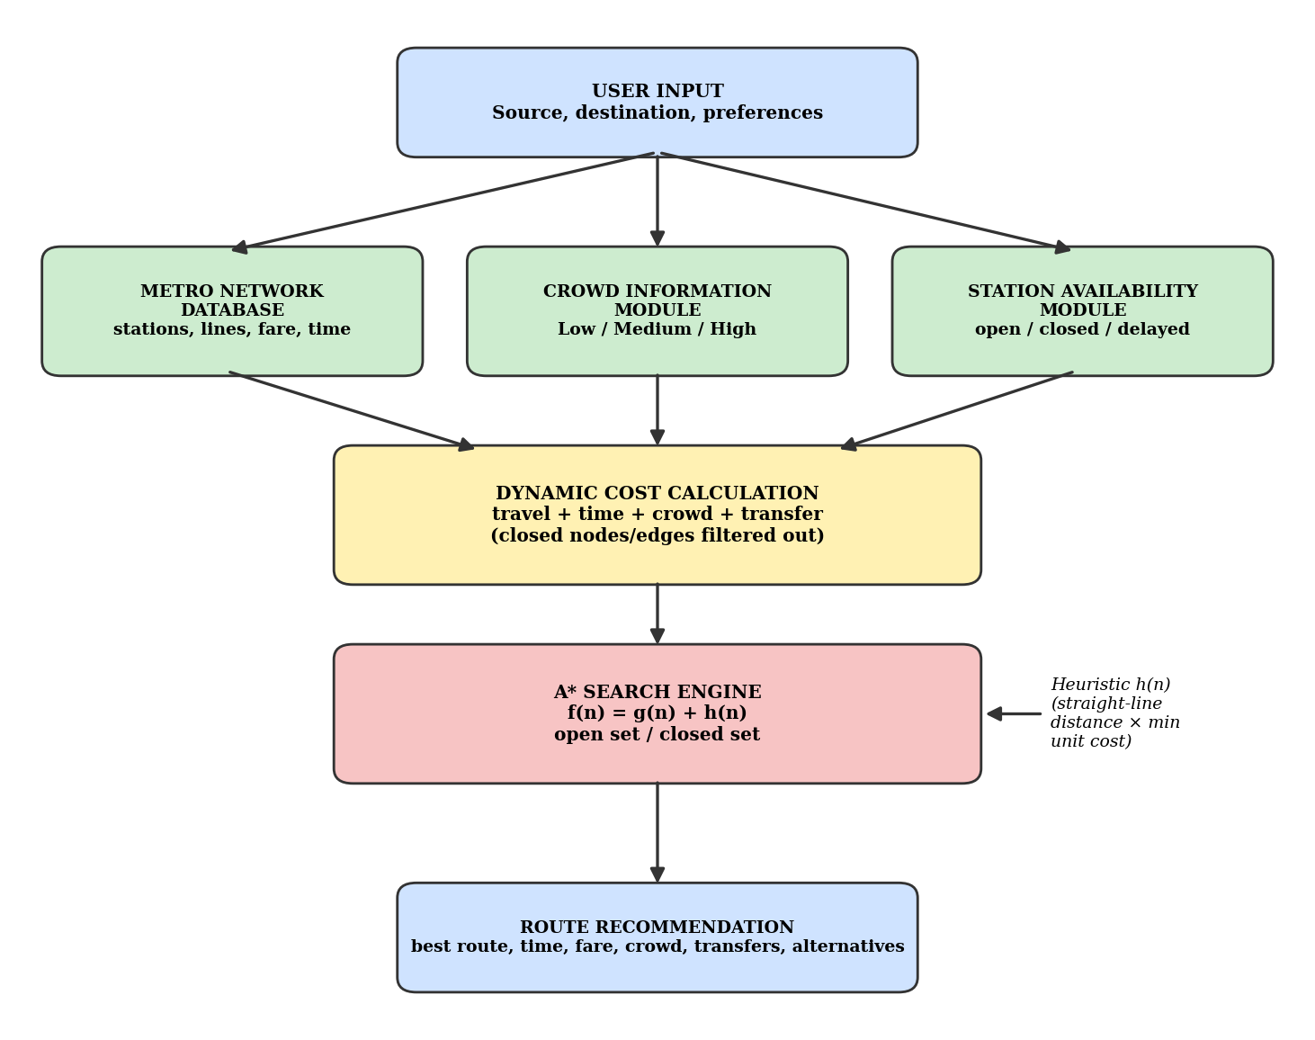
Fig. 3.1 System architecture of AI Metro
The data flow is: the user supplies the source, destination and optional preferences; the metro network database, crowd information module and station availability module supply the current state of the network; the dynamic cost calculation module turns that state into edge costs and removes unavailable elements; the A* search engine, guided by the heuristic h(n), finds the optimal path and alternatives; and the route recommendation module presents the result to the user.

3.2 PROBLEM FORMULATION AS GRAPH SEARCH
The network is an undirected graph G = (V, E). Each node is a station and each edge is a track segment between two adjacent stations on one line, so that travel is possible in both directions. An interchange station belongs to more than one line.
Because a transfer penalty applies when the passenger changes line, the cost of an edge depends on the line on which the passenger arrived. A* therefore searches over states (station, line) rather than over stations alone. The start state is (source, none), which lets the passenger board any line at the source without penalty. A state is a goal if its station equals the destination. This formulation keeps the cost of every move independent of the path history beyond the current state, which is the condition required for A* to remain optimal.

3.3 EDGE COST FUNCTION
The key difference between AI Metro and plain Dijkstra or breadth-first search is the cost of an edge, defined as
edge_cost = travel_cost + time_cost + crowd_penalty + transfer_penalty
and the cost of a path is the sum of its edge costs. The four components are described in Table 3.1.
Table 3.1 Components of the edge cost and default parameters
Component | Definition | Default value
travel_cost | Fare of the segment, proportional to its length | Rs 2.0 per km × w_fare
time_cost | Running time plus dwell time of the segment, plus extra minutes if the segment is marked DELAYED | 1.5 min/km + 1.0 min dwell (+6 min if delayed) × w_time
crowd_penalty | Penalty for the crowd level of the segment: the higher of the segment’s own level and the level of the station being entered | Low = 0, Medium = 4, High = 10, × w_crowd
transfer_penalty | Added only when the line used on this edge differs from the line used to arrive at the station | 8 × w_transfer

The weights w_fare, w_time, w_crowd and w_transfer default to 1 and are re-set by the user’s preference. Four presets are provided: Balanced (1, 1, 1, 1), Fastest (0.5, 3, 0.3, 0.5), Least crowded (0.5, 0.7, 4, 1) and Fewest transfers (0.5, 0.7, 0.7, 4). All weights are non-negative, so every edge cost is non-negative as A* requires. In the reported trip time, each transfer additionally adds 4 minutes of walking and waiting.

3.4 HEURISTIC FUNCTION
The heuristic estimates the remaining cost from a state to the destination using only the station’s straight-line distance d(n, goal) in kilometres:
h(n) = k × d(n, goal)
where k is the smallest value, over all usable edges e, of (travel_cost(e) + time_cost(e)) divided by the straight-line length of e. Scaling by k puts the heuristic in the same units as g(n). In the sample network k = 4.137 cost units per km under the Balanced preset.
Admissibility. Any path from n to the goal consists of edges e1, e2, …, em. The cost of each edge is at least k times its straight-line length because the crowd and transfer penalties are never negative. By the triangle inequality the sum of the straight-line lengths is at least d(n, goal). Hence the true remaining cost is at least k × d(n, goal), so h never over-estimates. Consistency. For any edge (u, v), h(u) − h(v) ≤ k × d(u, v) ≤ cost(u, v), so h is also consistent and a state never needs to be re-opened after it is closed. When an unavailable edge is removed, k is recomputed over the remaining edges, so the heuristic always matches the filtered graph.

3.5 A* ALGORITHM
A* keeps an open set of generated states waiting to be expanded, held in a priority queue ordered by f(n) = g(n) + h(n), and a closed set of states already expanded. At each step the state with the lowest f is removed from the open set and added to the closed set. If its station is the destination, the search stops and the path is rebuilt through parent links; otherwise each usable neighbouring edge is relaxed. The pseudocode is shown below.
A_STAR(source, destination, preferences):
1 remove closed / maintenance / disrupted stations and edges
2 k <- min over usable edges of (travel+time cost)/straight-line km
3 start <- (source, no line); g[start] <- 0
4 OPEN <- priority queue by f; push start, f = k*dist(source,dest)
5 CLOSED <- empty set
6 while OPEN is not empty:
7 n <- state in OPEN with the lowest f(n)
8 if n is in CLOSED: continue
9 add n to CLOSED
10 if station(n) = destination:
11 return path (follow parent links) and g[n]
12 for each usable edge (station(n) -> m) on line L:
13 c <- travel + time + crowd (+ transfer if L != line(n))
14 g2 <- g[n] + c
15 if g2 < g[(m, L)]:
16 g[(m, L)] <- g2; parent[(m, L)] <- n
17 push (m, L) with f = g2 + k*dist(m, destination)
18 return 'no route available'

The implementation is an explicit loop over Python’s heapq priority queue, not a library call, and it records every expansion (step, station, line, g, h, f and size of the open set). This trace is what the demonstration screen and the console output display to explain how A* works.

3.6 AVAILABILITY FILTERING AND ALTERNATIVE ROUTES
Availability. Each station and each connection has a status: OPEN, DELAYED, CLOSED, MAINTENANCE or DISRUPTED. The last three statuses are hard constraints, so the corresponding station or edge is excluded from the graph before A* runs; it is never merely penalised. A DELAYED element stays in the graph but its time cost grows by a fixed number of minutes. Because statuses are looked up whenever an edge is considered, they can be toggled at run time and the next query automatically uses the new state without restarting the application.
Alternatives. After the best route is found, each segment of that route is banned in turn and A* is re-run. Every resulting route that differs from those already found and costs no more than 1.6 times the best cost is a candidate, and the two cheapest candidates are shown as alternatives. This is a simplified form of the edge-removal idea in Yen’s K-shortest-paths method.

4. MODULES DESCRIPTION
The prototype is organised into one component per box of the architecture diagram, so that each can be explained and tested separately. The module names are graph_model, crowd_module, availability_module, cost_calculator, astar_search and the recommender, together with the front end.

4.1 USER INPUT MODULE
The user chooses the source and destination stations from a searchable drop-down and optionally selects a preference: Balanced, Fastest, Least crowded or Fewest transfers. The module checks that the two stations are different and that both are currently open, then passes the query and the weight vector to the cost calculator.

4.2 METRO NETWORK DATABASE MODULE
This module stores the stations (name and schematic coordinates), the lines, and the segments between adjacent stations with their distance, fare and running time. The seeded sample network has 20 stations, 3 lines, 21 segments and 4 interchange stations, as summarised in Table 4.1 and drawn in Figure 4.1.
Table 4.1 Seeded sample network
Line | Stations | Terminals | Interchanges
Blue | 9 | Airport – Central | Guindy (Red), Nandanam (Green), Central (Red)
Green | 7 | Koyambedu – Thiruvanmiyur | Koyambedu (Red), Nandanam (Blue)
Red | 8 | Central – Guindy | Central (Blue), Koyambedu (Green), Guindy (Blue)

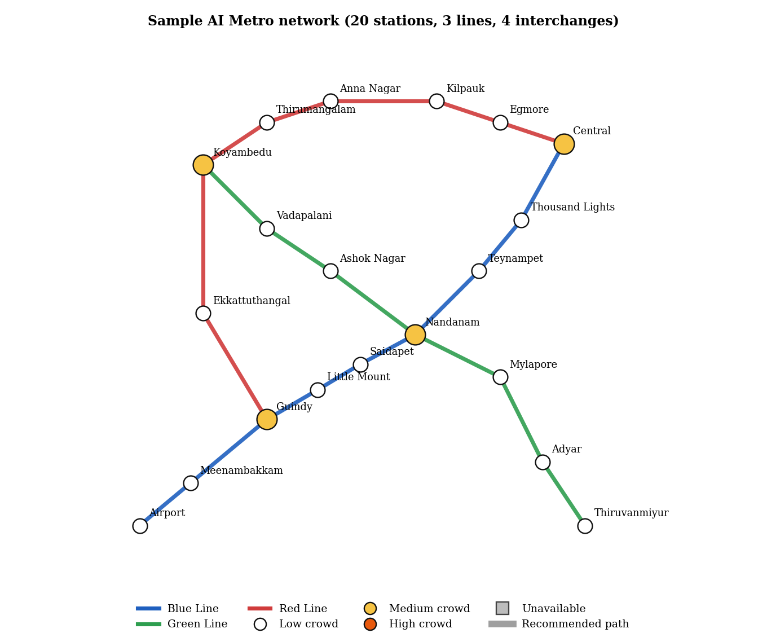
Fig. 4.1 Sample metro network used for evaluation
The Red and Blue lines together form a ring through Guindy, Koyambedu and Central, so most station pairs have more than one reasonable route; this is deliberate, because it lets crowd and closures change the answer. Distances are 1.1 times the straight-line length of each segment.

4.3 CROWD INFORMATION MODULE
The crowd module stores a level (Low, Medium or High) for every station and optionally for every segment. The effective crowd level of an edge is the higher of its segment level and the level of the station being entered. At start-up the four interchange stations are set to Medium to imitate peak hours. The levels can be changed one by one from a control panel, or re-drawn at random to simulate real-time change. A production system would fill this module from smart-card or sensor data instead.

4.4 STATION AVAILABILITY MODULE
This module stores the operational status of every station and connection and answers two questions for the search: whether an edge may be used at all, and how many extra minutes a DELAYED edge costs. Closing a station also disables every edge that touches it. Statuses can be toggled and reset from the control panel.

4.5 DYNAMIC COST CALCULATION MODULE
Given the graph, the current crowd levels, the current availability and the user’s weights, this module returns the cost of any edge using the formula in Section 3.3 and returns the breakdown into its four components for display. It also computes the heuristic scale k from the usable edges. Because the cost is evaluated when an edge is relaxed, a change in crowd or availability affects the very next search.

4.6 A* SEARCH ENGINE MODULE
The engine implements Section 3.5 and returns the path, its cost, the number of nodes expanded and generated, and the full expansion trace. It can also be run with h(n) = 0, which turns it into Dijkstra’s algorithm; this option is used to verify correctness and to measure the benefit of the heuristic in Chapter 5.

4.7 ROUTE RECOMMENDATION MODULE
This module converts a path into the output seen by the passenger: the station sequence and the lines used, total distance, total travel time (including transfer walking time), total fare (with a minimum fare of Rs 10), the number of transfers and where they occur, a crowd summary (the count of Low, Medium and High segments and an overall label) and up to two alternative routes generated as described in Section 3.6. If no path exists, it reports that no route is available.

4.8 FRONT END AND VISUALISATION
The front end is a responsive web page with four areas: (i) a station selector and preference control; (ii) a network view in which stations are coloured by crowd level, unavailable stations are shown in grey and the recommended path is highlighted over the lines; (iii) a control panel to change crowd levels, close or re-open stations and run a random-crowd simulation; and (iv) a results panel showing the route, time, fare, crowd summary, transfers and alternatives, with an A* trace table that lists the expanded nodes with their f, g and h values. A legend explains the colours of the normal, crowded and unavailable stations and edges.

5. IMPLEMENTATION AND RESULTS

5.1 EXPERIMENTAL SETUP
Implementation. The search engine is written in Python 3 using only the standard library (heapq, math, itertools and dataclasses); it is about 200 lines long and divided into the module sections of Chapter 4. The network figures in this report were drawn with Matplotlib. The same engine can be exposed through a lightweight API to the web front end described in Section 4.8.
Dataset. The 20-station network of Table 4.1 is used. Fares and times follow Table 3.1. The crowd and availability data are simulated; no real transit data are used.
Evaluation methods. Three kinds of evaluation were carried out. First, scenario tests examine whether the recommended route changes in the expected direction when crowd, availability or preferences change. Second, a correctness check compares A* with Dijkstra’s algorithm (the same code with h = 0), which is known to be optimal, for every station pair under normal conditions and for 200 random configurations of crowd levels, closures and preferences (30 random queries each, random seed 42). Third, an efficiency measurement counts the number of nodes expanded by each algorithm.

5.2 RESULTS

5.2.1 Scenario 1: A* trace for a multi-hop, one-transfer trip
The passenger travels from Airport to Thiruvanmiyur under normal peak-hour crowd and the Balanced preference. The recommended route is Airport – Meenambakkam – Guindy – Little Mount – Saidapet – Nandanam (change from Blue to Green) – Mylapore – Adyar – Thiruvanmiyur: 15.6 km, 35 minutes, fare Rs 31, one transfer, with 6 Low and 2 Medium crowd segments. The total cost is 78.70 and no alternative falls within the 1.6 times tolerance.
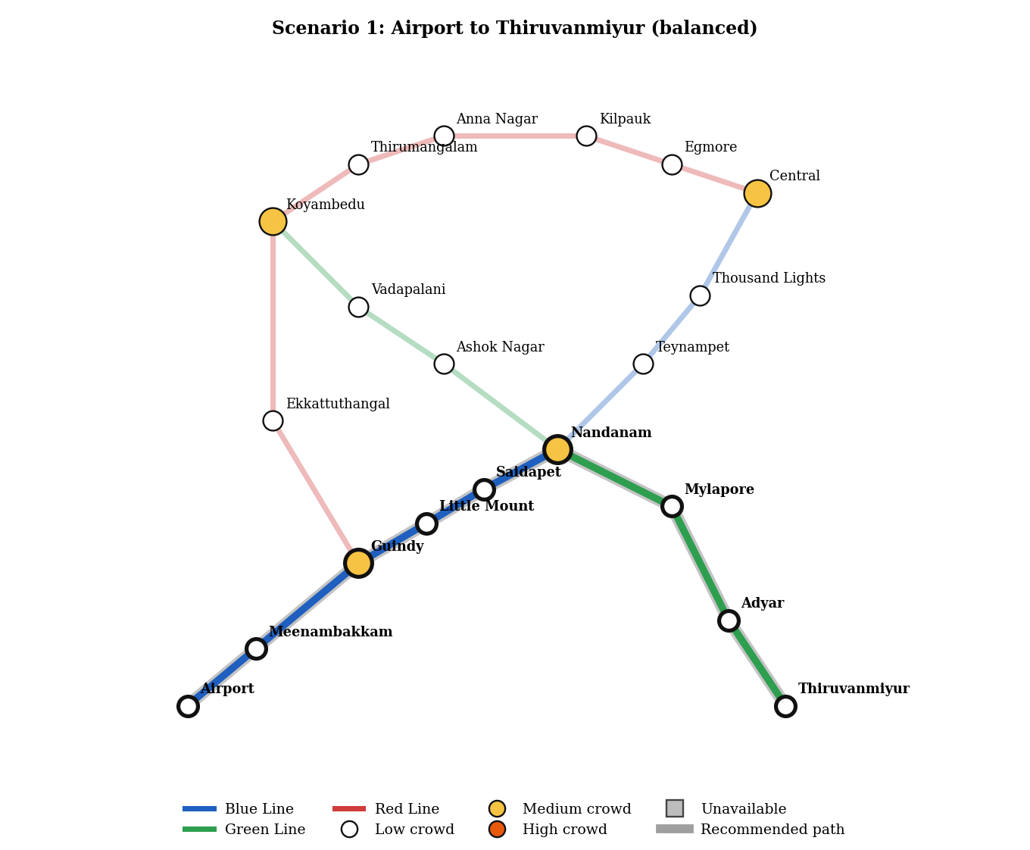
Fig. 5.1 Recommended route for Airport to Thiruvanmiyur
Table 5.1 A* expansion trace for Airport to Thiruvanmiyur
Step | State expanded (station, line) | g(n) | h(n) | f(n) | Open set after removal
1 | Airport (start) | 0.00 | 43.44 | 43.44 | 0
2 | Meenambakkam (Blue) | 7.02 | 38.70 | 45.72 | 0
3 | Guindy (Blue) | 21.05 | 32.71 | 53.76 | 1
4 | Little Mount (Blue) | 27.40 | 29.23 | 56.63 | 2
5 | Airport (Blue) | 14.04 | 43.44 | 57.48 | 2
6 | Saidapet (Blue) | 32.88 | 26.98 | 59.86 | 1
7 | Nandanam (Blue) | 43.55 | 24.91 | 68.46 | 1
8 | Mylapore (Green) | 61.16 | 16.68 | 77.84 | 3
9 | Adyar (Green) | 70.77 | 7.46 | 78.23 | 4
10 | Thiruvanmiyur (Green) | 78.70 | 0.00 | 78.70 | 4

The trace shows the behaviour described in Chapter 3. The f value never decreases from one expansion to the next, which reflects the consistency of h. At step 5 the state (Airport, Blue) is expanded because the state space includes the line, so a station can legitimately appear again with a different line; this expansion does not lead anywhere better and the search moves on. At step 8 the cost rises from g = 43.55 at Nandanam to g = 61.16 at Mylapore; 8.00 of that increase is the transfer penalty for changing from Blue to Green. A* expanded 10 states and generated 13, whereas Dijkstra’s algorithm expanded 21 states and returned the same cost of 78.70.

5.2.2 Scenario 2: Effect of crowd level
The passenger travels from Koyambedu to Thousand Lights. Under normal conditions the best route follows the Green Line to Nandanam, changes to the Blue Line and continues to Thousand Lights (Figure 5.2a). The alternative uses the Red Line to Central and then the Blue Line. Next, heavy crowding is simulated by setting Vadapalani, Ashok Nagar and Nandanam and the segment between Ashok Nagar and Nandanam to High. The recommendation switches to the Red Line route (Figure 5.2b), although it is longer by 1.1 km and 2 minutes. The Green route is now shown only as an alternative, with a crowd summary of High.
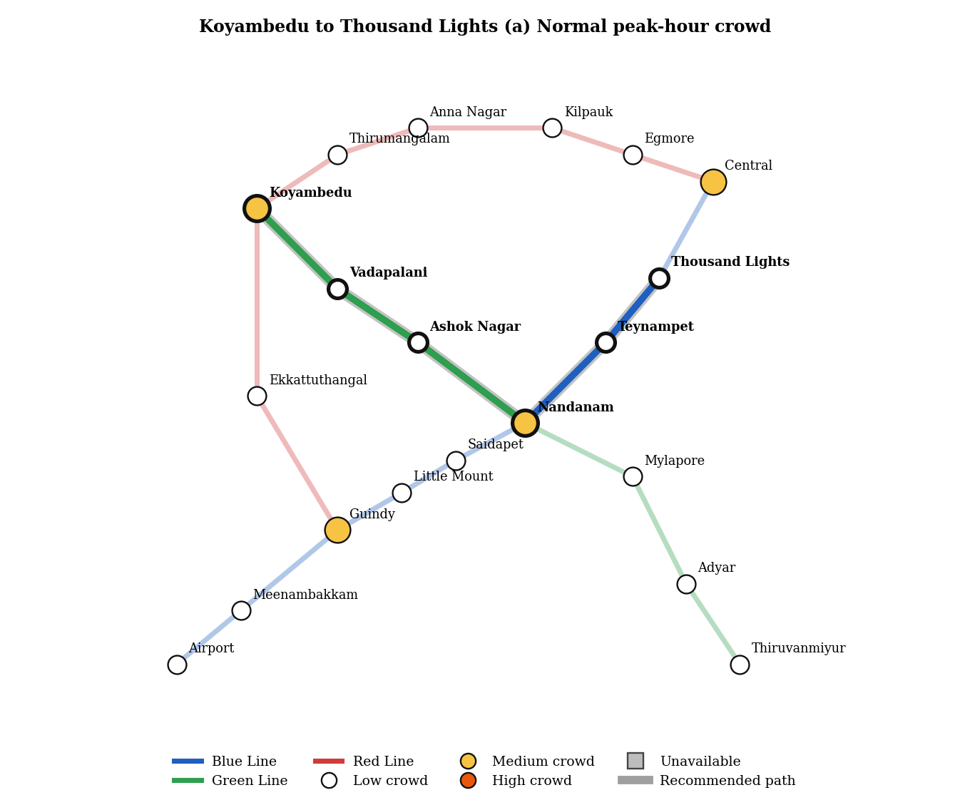
Fig. 5.2(a) Koyambedu to Thousand Lights, normal peak-hour crowd
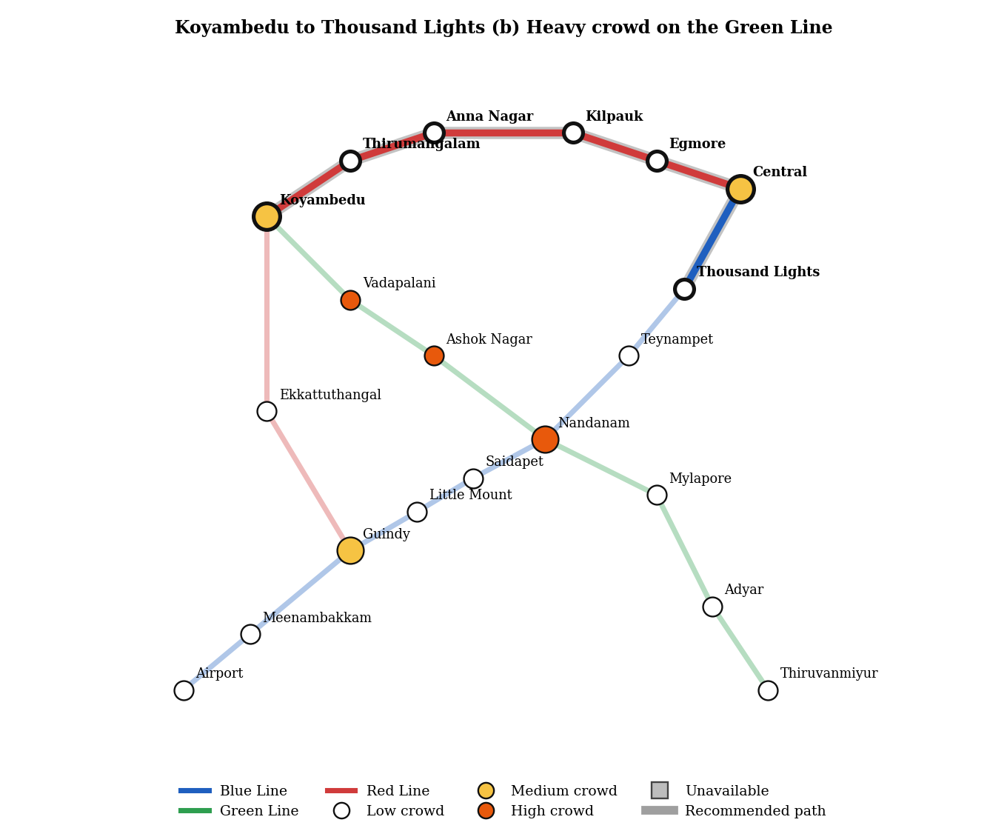
Fig. 5.2(b) Koyambedu to Thousand Lights, heavy crowd on the Green Line
Table 5.2 Effect of crowd on the route from Koyambedu to Thousand Lights
Condition | Route (transfer station) | Time (min) | Fare (Rs) | Transfers | Crowd | Cost
Normal – best | Green + Blue (Nandanam) | 26 | 22 | 1 | Low | 55.89
Normal – alternative | Red + Blue (Central) | 28 | 24 | 1 | Low | 60.77
Heavy crowd – best | Red + Blue (Central) | 28 | 24 | 1 | Low | 60.77
Heavy crowd – alternative | Green + Blue (Nandanam) | 26 | 22 | 1 | High | 81.89

The route that is fastest on paper is no longer the best once crowd is priced in, which is exactly the behaviour that distance-only planners cannot show. Its raw time and fare are unchanged; only its crowd penalty has risen.

5.2.3 Scenario 3: Effect of delays, closures and maintenance
The passenger travels from Koyambedu to Teynampet. Table 5.3 compares four situations.
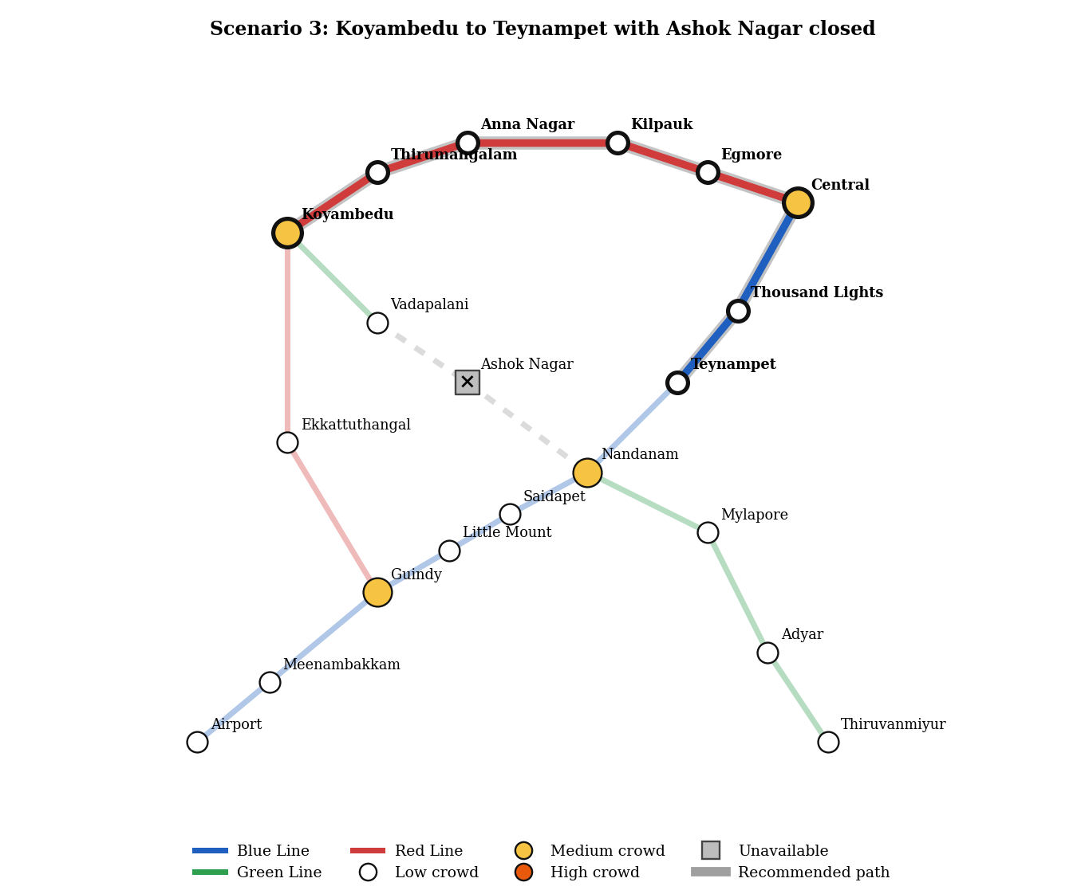
Fig. 5.3 Koyambedu to Teynampet with Ashok Nagar closed
Table 5.3 Effect of availability on the recommended route
Condition | Route | Time (min) | Fare (Rs) | Transfers | Cost
All open | Green + Blue via Ashok Nagar, Nandanam | 22 | 19 | 1 | 48.87
Ashok Nagar DELAYED | Same route (+6 min delay) | 34 | 19 | 1 | 60.87
Ashok Nagar CLOSED | Red + Blue via Thirumangalam … Central, Thousand Lights | 32 | 28 | 1 | 67.79
Ashok Nagar CLOSED (alternative) | Red + Blue via Ekkattuthangal, Guindy, Nandanam | 31 | 28 | 1 | 70.37

A delayed station stays in the graph and the route is kept because the detour (cost 67.79) is still more expensive than waiting (cost 60.87). A closed station is removed completely, so the planner reroutes around it, and the next-best route is offered as an alternative. Two further tests used maintenance at Nandanam, an interchange. For Airport to Teynampet the normal route is a direct Blue Line trip of 23 minutes and Rs 22 with no transfer; with Nandanam under maintenance the planner returns a 57-minute, Rs 51 route with two transfers that goes around the Red Line ring. For Koyambedu to Adyar, no route exists because Mylapore, Adyar and Thiruvanmiyur are reachable only through Nandanam, and the system correctly reports that no route is available instead of returning an invalid path.

5.2.4 Scenario 4: Effect of user preferences
The passenger travels from Koyambedu to Guindy while the Red Line segment between Koyambedu and Ekkattuthangal and the station Ekkattuthangal are set to High. Table 5.4 shows the result for each preference. The direct Red Line trip (no transfer, 13 minutes) is recommended by the Balanced, Fastest and Fewest transfers presets, while the Least crowded preset chooses the Green–Blue trip through Nandanam that is twice as long but avoids the crowded Red Line section.
Table 5.4 Route chosen for each preference (Koyambedu to Guindy)
Preference | Route | Time (min) | Fare (Rs) | Transfers | Crowd segments (L/M/H) | Nodes expanded
Balanced | Red, direct | 13 | 14 | 0 | 0 / 1 / 1 | 6
Fastest | Red, direct | 13 | 14 | 0 | 0 / 1 / 1 | 4
Least crowded | Green + Blue via Nandanam | 27 | 23 | 1 | 4 / 2 / 0 | 18
Fewest transfers | Red, direct | 13 | 14 | 0 | 0 / 1 / 1 | 6

Costs are not compared across presets because each preset uses different weights. The Fastest and Fewest transfers presets accept the crowding because time and transfers dominate their cost, while the Least crowded preset pays 14 extra minutes to ride a Low-crowd route.

5.2.5 Correctness and efficiency of A*
Table 5.5 compares A* with Dijkstra’s algorithm. Under normal conditions all 380 ordered station pairs were tested. In the randomised test, 6,000 queries were run on 200 random configurations in which each station’s crowd level was drawn at random, two stations were closed, put under maintenance or marked disrupted, and one of the four presets was chosen. Of these queries, 1,956 had no route (both algorithms agreed on this) and 4,044 had a route.
Table 5.5 A* versus Dijkstra’s algorithm
Experiment | Routes compared | Cost mismatches | A* nodes expanded (mean) | Dijkstra nodes expanded (mean) | Reduction
Normal crowd, all station pairs | 380 | 0 | 7.34 | 12.78 | 42.5%
Random crowd, closures and presets | 4,044 | 0 | 8.59 | 11.10 | 22.7%

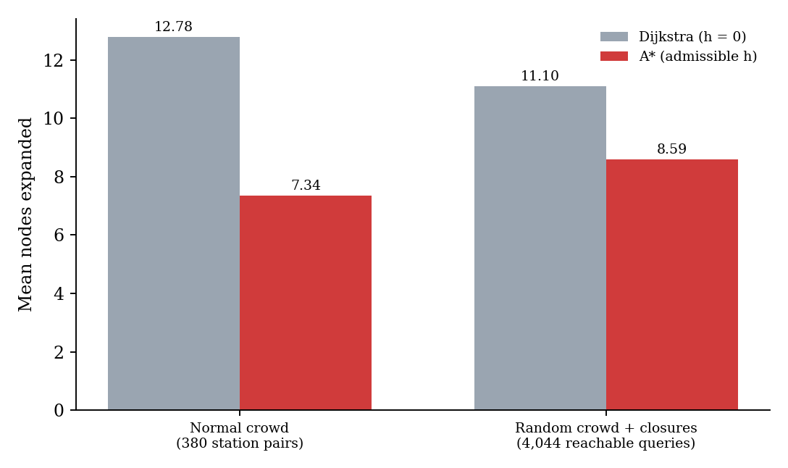
Fig. 5.4 Mean number of nodes expanded by Dijkstra and A*
In all 4,424 comparisons A* returned exactly the same cost as Dijkstra’s algorithm, which supports the admissibility argument of Section 3.4. A* expanded fewer nodes in both experiments. The saving is smaller in the random experiment because crowd penalties and closures make the real remaining cost larger than the straight-line estimate, so the heuristic is less tight. Since the sample network is small, the absolute numbers are small; the percentage reduction is the meaningful result.

5.2.6 Discussion
- The recommended route is the minimum-cost route under the chosen cost function, not necessarily the shortest in km or minutes.
- Crowd levels move the recommendation only when a plausible alternative exists within a reasonable cost; otherwise the planner keeps the original route.
- Hard exclusion of unavailable elements guarantees that a closed station is never recommended and that unreachable destinations are reported.
- Preferences re-weight the same formula, so the user can trade time against comfort without changing the algorithm.
- The trace of expanded states, with g, h and f values, makes every recommendation explainable.
Limitations. The network is a small, schematic sample; crowd and availability data are simulated; the fare is a simple distance-proportional model rather than a real fare table; and the penalty values (4 and 10 for crowd, 8 for a transfer) are chosen for demonstration and were not calibrated against passenger behaviour.

6. CONCLUSION AND FUTURE WORK
This project-built AI Metro, a crowd-aware metro route planner based on A* search. The network is a weighted graph, the edge cost combines fare, time, crowd and transfer penalties, unavailable stations and connections are removed before the search, and an admissible, consistent straight-line heuristic keeps the result optimal. The A* implementation is written explicitly and exposes its open and closed sets and f, g and h values so that it can be explained. Tests on a 20-station, 3-line network showed that A* matched Dijkstra’s algorithm in all 4,424 comparisons while expanding fewer nodes, and that the recommended route reacts correctly to crowding, delays, closures and user preferences.
Future work:
The prototype can be extended in the following directions:
- Replace the simulated crowd data with live or historical passenger-load data, for example from smart-card taps or platform sensors.
- Use a real fare table, real timetables and train frequencies, so that waiting time at transfers is modelled instead of a fixed value.
- Learn the crowd and transfer penalties from passenger choice data instead of fixing them by hand.
- Predict crowd levels for the planned time of travel with a machine-learning model and use the prediction in the cost function.
- Replace the simplified alternative-route method with Yen’s full K-shortest-paths algorithm, and support multi-modal journeys with buses and walking.

7. REFERENCES

Bast, H., Delling, D., Goldberg, A., Müller-Hannemann, M., Pajor, T., Sanders, P., Wagner, D. and Werneck, R.F. (2016) ‘Route Planning in Transportation Networks’, in Algorithm Engineering, Lecture Notes in Computer Science, Vol.9220, Springer, pp.19-80.
Dijkstra, E.W. (1959) ‘A note on two problems in connexion with graphs’, Numerische Mathematik, Vol.1, No.1, pp.269-271.
Goldberg, A.V. and Harrelson, C. (2005) ‘Computing the shortest path: A* search meets graph theory’, Proceedings of the 16th Annual ACM-SIAM Symposium on Discrete Algorithms, pp.156-165.
Hart, P.E., Nilsson, N.J. and Raphael, B. (1968) ‘A Formal Basis for the Heuristic Determination of Minimum Cost Paths’, IEEE Transactions on Systems Science and Cybernetics, Vol.4, No.2, pp.100-107.
Kroes, E., Kouwenhoven, M., Debrincat, L. and Pauget, N. (2013) ‘Value of crowding on public transport in Île-de-France, France’, Transportation Research Record, No.2417, pp.37-45.
Pallottino, S. and Scutellà, M.G. (1998) ‘Shortest path algorithms in transportation models: classical and innovative aspects’, in Equilibrium and Advanced Transportation Modelling, Kluwer Academic Publishers, pp.245-281.
Pearl, J. (1984) Heuristics: Intelligent Search Strategies for Computer Problem Solving, Addison-Wesley.
Pelletier, M.-P., Trépanier, M. and Morency, C. (2011) ‘Smart card data use in public transit: A literature review’, Transportation Research Part C, Vol.19, No.4, pp.557-568.
Russell, S. and Norvig, P. (2021) Artificial Intelligence: A Modern Approach, 4th edn, Pearson.
Wardman, M. and Whelan, G. (2011) ‘Twenty years of rail crowding valuation studies: Evidence and lessons from British experience’, Transport Reviews, Vol.31, No.3, pp.379-398.
Yen, J.Y. (1971) ‘Finding the K shortest loopless paths in a network’, Management Science, Vol.17, No.11, pp.712-716.

